Ester Synthesis Via Alkyl Halide
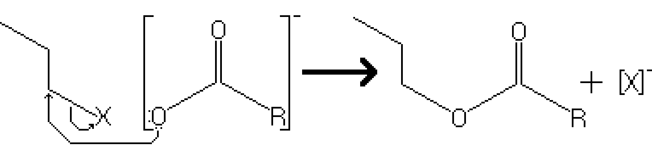
Reactants – Primary Alkyl Halide, NaOOR
Products – Primary Ester, Na⁺
Electron Movement
- SN2 Reaction – The electrons on the negatively charged oxygen of the ester group, acting as the nucleophile, attack the carbon bonded with the alkyl group. The alkyl group acts is a good leaving group, causing the displacement of the alkyl halide.

Notes
- Since this reaction is based on the Sn2 mechanism, there are several conditions that may increase the rate of reaction
  - The alkyl halide must be either a methyl halide or primary halide due to a lower activation energy.
  - If in a solution, having the reactants in a polar aprotic solvent greatly increases rate of reaction.

